WVSSAC ISSUES STATEMENT REGARDING MARCHING BAND
Released: August 25, 2020
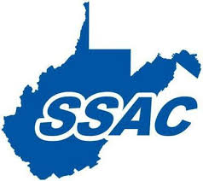
Yesterday, a recommendation was released regarding the participation of middle and high school marching bands at football games.
Since that recommendation was released, the WVSSAC has had additional discussions with state health officials, the WVDE, and the WV Bandmaster’s Association. Based on those discussions, the WVSSAC is recommending the following:
Middle and high school marching bands be allowed to attend and perform pre-game (National Anthem) and half-time shows at HOME football games with the following modifications:
- Designation of a separate seating area for band members (not in the bleachers)
- Designation of a separate seating area for band parents and families
- Requirement that band members maintain social distancing as per NFHS guidelines (6’ x 6’ and 9’ x 6’ for trombone players). A diamond formation is recommended.
- Requirement that only the percussion section be permitted to play during the game
- Requirement that face coverings be worn by all band members when not performing
- Recommendation that face coverings be worn while performing when possible (as per NFHS guidelines)
- Recommendation of use of instrument bell covers when possible (as per NFHS guidelines)
- Recommendation that band members and families enter and exit the facility separately from athletes and their families when possible
The same spectator guidelines used for football and cheer will be used for band.
WVSSAC Executive Director Bernie Dolan released the following statement: “We fully support the participation of band at football games. After further discussion, we believe this revised recommendation will allow participation while still maintaining safety protocols for everyone involved. We will monitor the situation closely knowing we may have to adjust again as we move forward.”

